1.0 Goal – Centered Design Document

1.1 An Introduction to the Virtual Placement Agency

Since 1970, TriLambda Employment Solutions (“TriLam”) has been helping North American companies find qualified people to fill their employment vacancies. More recently, TriLam has been witness to the rapid growth of the information technology sector, to the extent that the largest percentage of TriLam’s business is now in IT placements. Given this fact, they are endeavouring to adapt to a changing job market by introducing a specialized service for their high-tech client companies and job seekers: the Virtual Placement Agency (“VPA”).
From a utilitarian perspective, this VPA software application is intended to provide a system which will:
- store and track details about client companies which may have one or more employment opportunities that need to be filled
- store and track information about these positions, both while the position is active as well as after it has closed
- store and track profiles of applicants for positions, said profiles being submitted to the VPA by the applicants through various media (Internet, postal service, fax, etc.)
- match an applicant to an employment opportunity on the basis of how closely an applicant’s skill set corresponds to the requirements of an available position.

Project Goals

- It is the intention of I2I to provide TriLambda Employment Solutions with a user-friendly and easily managed product.
- I2I will maintain close consultation with our client at all phases of the design process.
- While creating the VPA application, I2I will adhere to the GUIDS methodology for object-oriented design.
- The VPA application will be able to function across a variety of platforms.
- I2I company standards dictate that the application be written in a structured, efficient manner.
- The program must be easy to maintain, and adaptable to an ever-changing business environment.

Business Objectives

- Maintain companies
- Maintain positions
- Maintain applicants
- Maintain skills
- Find position(s) for applicants
- Apply directly to a position

Technical Objectives

- The software will be developed using Visual Basic 6
- The design of the VPA application will follow Microsoft GUI standards
- “Back end” data storage will be done through Microsoft Access 97

1.2 Project Requirements

The use cases outline the typical business processes the Placement Application
will need to perform. These should be used to validate design decisions taken
throughout system development. The system should be designed to smooth
these processes.

See Appendix A for the Use Cases

TriLambda Employment Solutions Use Case Diagram

Maintain Positions
Maintain Companies
Maintain Applicants
Find Positions for Applicants
View Skills
Apply For Position
Maintain Skills
Place Applicant
Find Candidates for Positions
Charting Position/Applicant Skill Matching
Maintain Archive Table
E-mail Applicants
Maintain Security
Recruiter
Applicant
Database Administrator

1.3 Object Model

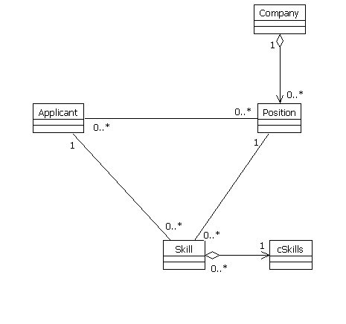

TriLamda Employment Solutions

Object Name | Purpose
Company | The company object is an instance of the company class. The purpose of the object is to relay the information about a company to the forms. An example of this object is the company named Watermark Solutions.
Applicant | The applicant object is an instance of the applicant class. The purpose of the object is to relay the information about an applicant to the forms. An example of an applicant is Jackson Ragouli.
Position | The position object is an instance of the position class. The purpose of the object is to relay the information about a position to the forms. An example of a position is Database Administrator.
Skills | The skills object is an instance of the skills class. The purpose of the object is to relay the information about skills to the forms. An example of a skill is Access.
cSkills | The skills collection (cSkills) is an instance of the skills collection class. The purpose of the skills collection is to manage the skills class. An example of a skills collection is all the skills that the industry determined were important on January 8, 1999.

1.4 Implementation Class Diagram

TriLambda Employment Solutions
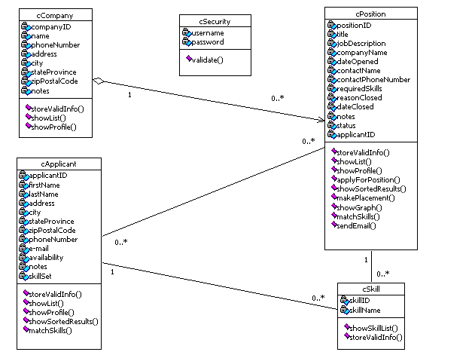

Classes

Class Name | Description
cCompany | The Company Class will manage information about client companies within the VPA.
cApplicant | The Applicant Class will manage information about applicants within the VPA.
cPosition | The Position Class will manage information about positions within the VPA.
cSkill | The Skill Class will manage information about industry skills.
cSecurity | The Security Class manages information about user names and passwords.

Class Properties and Methods

cCompany Class Properties | Description
companyID | Provides a unique ID number for each company.
name | Provides the full name of the company.
phoneNumber | Provides the phone number of the company.
address | Provides the address of the company.
city | Provides the city the company is located in.
stateProvince | Provides the state or province the company is located in.
zipPostalCode | Provides the zip or postal code of the company.
notes | Provides any other relevant information about the company.

cCompany Methods | Description
storeValidInfo() | Allows the object to use information input by the user. Ensures that all required fields are filled with appropriate information. Saves the valid information to the database. If the data is invalid, this method will inform the user and allow them to make changes before saving to the database.
showProfile() | Relays the information about a selected company to the Company Form (frmCompany).
showList() | Shows the list of companies to the Company Form (frmCompany) and the Position Form (frmPosition), which will allow the user to select a company.

cApplicant Properties | Description
applicantID | Provides a unique ID number for each applicant.
firstName | Provides the first name of the applicant.
lastName | Provides the last name of the applicant.
address | Provides the address of the applicant.
city | Provides the city the applicant is located in.
stateProvince | Provides the state or province the applicant is located in.
phoneNumber | Provides the phone number of the applicant.
e-mail | Provides the e-mail address of the applicant.
availablity | Provides information on whether or not an applicant is available for placement.
zipPostalCode | Provides the zip or postal code of the applicant.
notes | Provides relevant information about the applicant.
skillSet | Provides a list of skills that the applicant has.

cApplicant Methods | Description
storeValidInfo() | Allows the object to use information input by the user. Ensures that all required fields are filled with appropriate information. Saves the valid information to the database. If the data is invalid, this method will inform the user and allow them to make changes before saving to the database.
showProfile() | Relays the information about a selected applicant to the Applicant Form (frmApplicant).
showList() | Relays the list of applicants to the Find Position Form (frmFindPosition) which will allow the user to select an applicant.
showSortedResults() | After skills have been matched this method will display the results sorted by best fit.
matchSkills() | Compares the applicant skill set with the position’s required skills. It then sorts the information in order of the percentage of required skills met.

cPosition Properties | Description
positionID | Provides a unique ID number for each position.
title | Provides a title for each position.
jobDescription | Provides a job description for each position.
companyName | Provides the name of the company who has posted the position.
dateOpened | Provides the date which the position opened to applicants.
contactName | Provides the name of a contact at the company who is posting the position.
contactPhoneNumber | Provides a phone number for the contact at the company.
requiredSkills | Provides a list of the skills which the applicant will need to qualify for the position.
reasonClosed | Provides the reason the position has been closed (cancelled, filled)
dateClosed | Provides the date on which the position was closed.
notes | Provides any relevant information about the position.
status | Provides information as to whether the position is open or closed.
applicantID | Provides a unique ID number for each applicant.

cPosition Methods | Description
showList() | Allows the object to take a list of positions from the database and show the list of positions to the Position Form (frmPosition).
storeValidInfo() | Allows the object to use information input by the user. Ensures that all required fields are filled with appropriate information. Saves the valid information to the database. If the data is invalid, this method will inform the user and allow them to make changes before saving to the database.
showProfile() | Shows the information about a selected position to the Position Form (frmPosition).
applyForPosition() | This allows the applicant to apply for a specific position through a web interface.
showSortedResults() | After skills have been matched this method will display the results sorted by best fit.
makePlacement() | Allows the recruiter to close the position and take the applicant off the available list.
showGraph() | Sends the sorted results of the matchSkills() method in cPosition, to Excel, where an Excel Pie Chart is created and then displayed to the user.
cPosition Methods | Description
matchSkills() | Compares the applicant skill set with the position’s required skills. It then sorts the information in order of the percentage of required skills met.
sendEMail() | Allows the recruiter to use Outlook to send a generic E-Mail to the eligible applicants alerting them that they will be contacted shortly. It also displays the number of messages sent out per position.

cSkill Properties | Description
skillID | Provides a unique ID number for each skill.
skillName | Provides the name of the skill.

cSkill Methods | Description
showSkillList() | Shows the complete list of industry skills in the list box on the skills form. It also sends a list of selected skills to the Applicant (frmApplicant) and Position (frmPosition) forms.
storeValidInfo() | Allows the object to use information input by the user. Ensures that all required fields are filled with appropriate information. Saves the valid information to the database. If the data is invalid, this method will inform the user and allow them to make changes before saving to the database

colSkills Methods | Description
add() | Creates a new instance of the skills class and puts it in the Skills Collection (colSkills).
remove() | Deletes and instance from the Skills Collection (colSkills).
item() | An index to find and item in the collection.
count() | Counts the number of items in the collection.

cSecurity Properties | Description
userName | Provides the Recruiter with a name to use in order to access the application.
Password | Provides the Recruiter with a unique password to use in order to access the application.

cSecurity Methods | Description
validate() | Verifies that the user name and password match and are valid.

Relationships

Class | Class | Description
Company | Position | The relationship is an aggregation. One company may have zero or more positions.
Applicant | Skill | The relationship is an association. Skills and applicants will exist independently of one another. One applicant will use one or many skills.
Applicant | Position | This relationship is an association. Applicants and positions will exist independently of one another. A position can have zero or many applicants. An applicant can apply for zero or more positions.
Position | Skill | This relationship is an association. A position will use one or many skills.
Skills Collection | Skill | This relationship is an aggregation. The collection will not exist without skills. One or more skills will make up one collection.

2.0 User – Interface Design Document

2.1 User Objectives

Overview

The user requirements defined below were derived through interviews with personnel from TriLambda Employment Services and a review of the preliminary processes produced by I2I. End-user requirements were then transformed into functional requirement by converting them from current process terminology to a more goal-oriented statement. The resulting requirements are the basis of the object model and scenarios produced as a result.

User Objectives

To provide the sales team of TriLambda Employment Solutions with a user-friendly application that is both simple to use and capable of performing all the required tasks. The following are the defined and more specific requirements.

- Incorporates correct naming conventions.
- The application will be bound with and MDI Form.
- Make use of menus and toolbars via access (hot) keys.
- Maintain the current organization’s standards
- Allow the user to have a wide range of control over the application such as minimizing the screens.

Plan for Satisfying Goals

- The interface must be easy to use.
- The interface must require minimal training of Users to operate.
- The system must support current platform/application architecture.
- The system must not affect existing applications.
- The module must assist and not impede users in sales tasks.
- Accessibility (via the Internet) must be available to TriLam Users.

2.2 Form Functionality

Each of the forms will contain GUI validation that will allow for a higher level of overall functionality. The forms will be coded to check for any data that the user enters for proper formatting and validity. Only valid data (such as proper dates) will be allowed to enter the database. This also prevents the user from leaving required fields empty when entering new information. All the forms will be validated at both a GUI and Database level, although this validation will not prove annoying to the user through proper training and coding techniques.

2.3 Screen Shots
MDI Form

The MDI form provides a means to access the other forms in the application. It is a secure form which only allows a user with a password to enter the application.
1
2
3
4
5
6
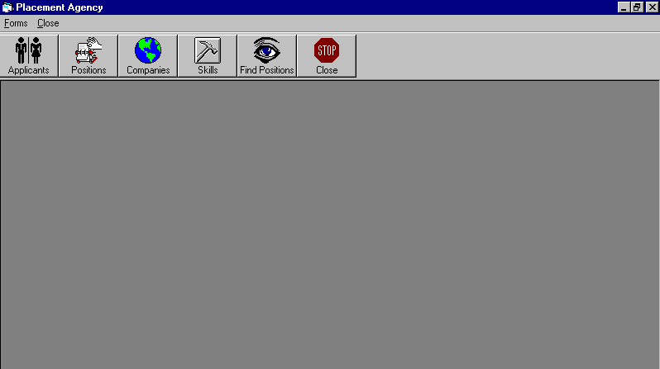

 | Control Name | Type | R/W | Description
1 | Applicant | Menu bar button | …. | Opens the Application form
2 | Positions | Menu bar button | …. | Opens the Positions form
3 | Companies | Menu bar button | …. | Opens the Companies form
4 | Skills | Menu bar button | …. | Opens the Skills form
5 | Find Positions | Menu bar button | …. | Opens the Find Positions form
6 | Close | Menu bar button | …. | Closes all forms

MDI Form
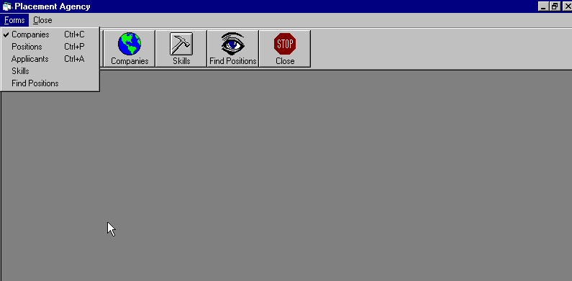
1
2
3
4
5

 | Control Name | Type | R/W | Description
1 | Companies | Menu Control | …. | Opens the Companies form
2 | Positions | Menu Control | …. | Opens the Positions form
3 | Applicants | Menu Control | …. | Opens the Applicants form
4 | Skill | Menu Control | …. | Opens the Skill form
5  1 | Find Positions | Menu Control | …. | Opens the Find Positions form
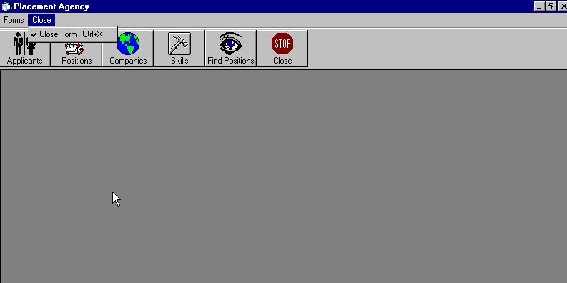
 | Control Name | Type | R/W | Description
1 | Close | Menu Control | …. | Closes the MDI form
Applicant Form

The applicant form will be used by the Recruiter to create or edit applicant
profiles. The Recruiter will also be able to open the Skills form to view a list
industry skills possessed by each applicant.

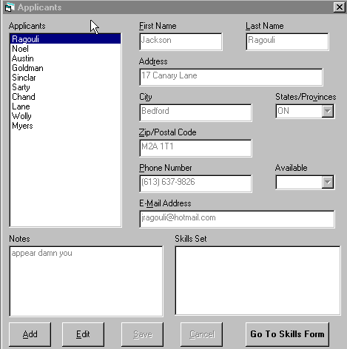
1
2
3
4
5
6
7
8
10
11
12
13
14
15
16
17
9

Applicant Form

 | Control Name | Type | R/W | Description
1 | Applicants | List Box | R | Is a control that by clicking the last name, you bring up all the information on that applicant.
2 | First Name | Text Box | R/W | Displays first name of applicant.
3 | Last Name | Text Box | R/W | Displays last name of applicant.
4 | Address | Text Box | R/W | Displays address of applicant.
5 | City | Text Box | R/W | Displays the city in which they live.
6 | State/Province | Combo Box | R | Provides a list of states and provinces from which the applicant makes their selection.
7 | Zip/Postal Code | Text Box | R/W | Displays zip code or postal code of applicant.
8 | Phone Number | Text Box | R/W | Displays phone number of applicant.
9 | Available | Combo Box | R | Displays whether the applicant is immediately available or not.
10 | E-Mail Address | Text Box | R/W | Displays e-mail address of applicant.
11 | Notes | Text Box | R/W | Displays any additional info for applicant.
12 | Skills | List Box | R | Displays all the skills that the applicant can choose from to describe their skills.
13 | Add | Command Button | R | Enables any visitor to this application to add their information so they can be on the applicant list.
14 | Edit | Command Button | R | Enables user to change info on any applicant.
15 | Save | Command Button | R | Saves the applicant’s entered info.
16 | Cancel | Command Button | R | Cancels the action.
17 | Go To Skills Form | Command Button | R | Links to Skills Form for applicant to specify skills.

Position Form

The position form will allow the Recruiter to create or edit profiles of various
positions. From the positions form the Recruiter will be able to access a list
of applicants by pressing the View Applicant’s List button. The Recruiter
will also be able to open the Skills form to view a list of industry skills
required for each position.
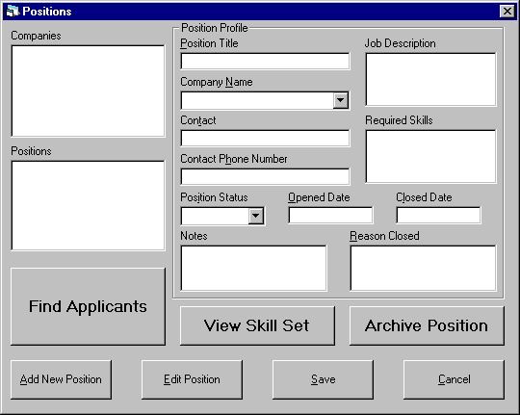
1
2
3
4
5
6

7
14
15
16
17
18
19
20

8
9
11
10
12
13

Position Form

 | Control Name | Type | R/W | Description
1 | Position Title | Text Box | R/W | Displays the title of the Job position.
2 | Companies | List Box | R | Displays a list of Companies.
3 | Contact Name | Text Box | R/W | Displays the company’s contact name
4 | Positions | List Box | R | Lists all positions from database
5 | Position Status | Combo Box | R | Dropdown list for position status
6 | Notes | Text Box | R/W | Displays the notes about the position.
7 | Find Applicants | Command Button | R | Displays Find Applicant/Position Form.
8 | Add Position | Command Button | R | Adds a new recordset to the database
9 | Edit Position | Command Button | R | Edits the current recordset selected from database
10 | View Skill Set Button | Command Button | R | Link to the Skills form.
11 | Save | Command Button | R | Saves the current recordset to the database
12 | Archive Position | Command Button | R | Sends Position to the Archive list.
13 | Cancel | Command Button | R | Cancels the changes to the current recordset.
14 | Reason Closed | Text Box | R/W | Displays the reason why the position closed
15 | Opened Date | Text Box | R/W | Displays the date the position opened
16 | Closed Date | Text Box | R/W | Displays the date the position closed
17 | Contact Phone Number | Text Box | R/W | Displays the company’s contact phone number
18 | Required Skills | Text Box | R/W | Displays a list of skills required for the position.
19 | Company Name | Combo Box | R | Dropdown list of all companies in the database
20 | Job Description | Text Box | R/W | Displays the position description and information.

Input Box For Position Form

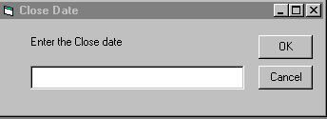
2
3
1

The close date will be entered into the textbox (1). A mouse-click of the “OK” button
(2) will save the entered information and enter it into the Positions table, and the next
input box will pop up. A mouse-click of the “Cancel” button (3) will cancel the process,
no close date will be saved, and the user will return to the Position form.

2
3
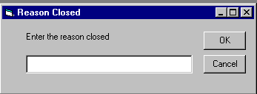
1

The reason for closure will be entered into the textbox (1). A mouse-click of the “OK”
button (2) will save the entered information and enter it into the Positions table, and the
the user will return to the Position form. A mouse-click of the “Cancel” button (3) will
cancel the process, no close date will be saved, and the user will return to the Positions
form.

Company Form
3

The company form will allow the Recruiter to create or edit a profile
of a client company.

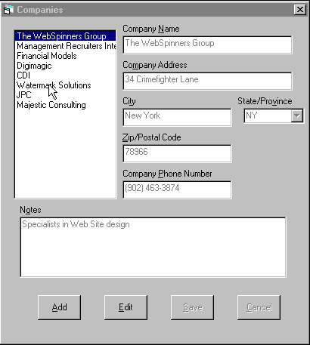
1
3
4
5
6
7
8
9
10
11
12

2

Company Form

 | Control Name | Type | R/W | Description
1 | Companies | List Box | R | This list box is used to display the full names of companies.
2 | Notes | Text Box | R/W | This text box is used to record and display notes on the company selected.
3 | Company Name | Text Box | R/W | This text box is used to display the full name of a selected company. It is also used to enter a new company name.
4 | Company Address | Text Box | R/W | This text box is used to display the full address of a selected company. It is also used to enter a new company address.
5 | State Province | Combo Box | R | This text box is used to display the state or province the company is located in. It is read only since the user can only select the state or province rather than type one in themselves.
6 | City | Text Box | R/W | This text box is used to display the city the selected company is located in. It is also used to enter a new city.
7 | Zip Postal Code | Text Box | R/W | This text box is used to display the zip/postal code of a selected company. It is also used to enter a new zip/postal code.
8 | Company Phone Number | Text Box | R/W | This text box is used to display the company phone number of a selected company. It is also used to enter a new company phone number.
9 | Add | Command Button | …. | This button is used when creating a new company profile. When pressed it enables the text boxes so that information may be added.
10 | Edit | Command Button | …. | This button is used when making changes to a company profile. It enables the text boxes allowing a user to change information.
11 | Save | Command Button | …. | This button is used when a new profile is created. When the button is pressed the information is sent to the database.
12 | Cancel | Command Button | …. | This button is used to cancel the creation of a new profile or to cancel the editing of a company profile.

Skill Form

The Skill form will be used by the Recruiter to add or edit the list of industry
skills. It will also be used when creating or editing applicant or position profiles.

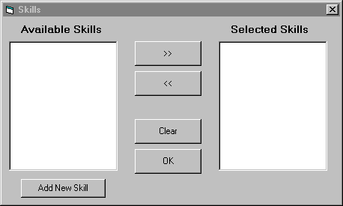
1
2
3
4
5
6
7

Skill Form

 | Control Name | Type | R/W | Description
1 | Available Skills | List box | R/W | This list box will contain a list of all the skills which may potentially be required for a position, and which an applicant may possess.
2 | Selected Skills | List box | R/W | This list box will be filled with all the skills selected from the Available Skills list box, either for adding to the required skills field of a position or to the skill set field of an applicant.
3 | Select | Command button | …. | Once a skill in the Available Skills box is highlighted, clicking on the cmdSelect button will move that skill to the Selected Skills list box.
4 | Remove | Command button | N/A | Once a skill in the Selected Skills box is highlighted, clicking on the cmdRemove button will remove that skill from the Selected Skills box.
5 | Clear | Command button | N/A | Clicking this button will clear all Selected Skills from the Selected Skills textbox.
6 | OK | Command button | N/A | By clicking this button, the contents of the Selected Skills box will populate either the Required Skills field of the Positions form, or the Skill Set field of the Applicants form, depending on which form called the Skills form.
7 | Add New Skill | Command button | N/A | Clicking this button will prompt an input box (see below) that will allow the Recruiter to add a new skill to the database and the Available Skills list.

Input Box for Skill Form

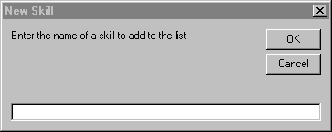
1
2
3

The name of a new skill will be entered into the textbox (1). A
mouse-click of the “OK” button (2) will save the entered information and enter it into the list of Available Skills, and the user will be returned to the Skills form. A mouse-click of the “Cancel” button (3) will cancel the process, no new skill will be saved, and the user will return to the Skills form.

Find Position Form

The find position form will be used to view a list of applicants and the jobs best
suited for a selected applicant. It will also be used to place applicants in a
particular position.

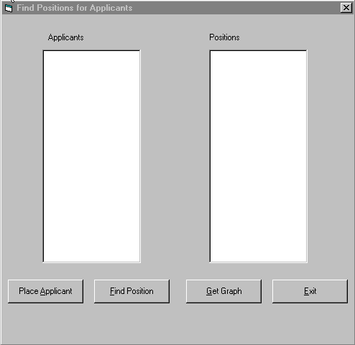

3 4 5 6

Find Position Form

 | Control Name | Type | R/W | Description
1 | Applicants | List Box | R | Displays a list of all available applicants’ full names.
2 | Positions | List Box | R | Displays a list of the positions open to the applicants. When the Find Position button is pressed it will display a list of jobs best suited for the selected applicant. The jobs will be listed in order of the best fit to the applicant in terms of required skills. When the Place Applicant button is pressed the list box will display a list of all open positions.
3 | Place Applicant | Command Button | …. | This button allows the user to call up a list of open positions and available applicants which will be displayed in the list boxes.
4 | Find Positions | Command Button | …. | This button allows the user to display a list of applicants and a list of positions best suited for a selected applicant.
5 | Get Graph | Command Button | …. | This button allows the user to display an Excel Pie Chart to quickly view the percentage of total applicants’ skills matching the positions’ skills.
6 | Exit | Command Button | …. | This button allows the user to exit the form.

Input Box for Find Position Form

1
2
3

This form is triggered on the click of the Place Applicant button.
The close date will be entered into the textbox (1). A mouse-click of the “OK” button
(2) will save the entered information and enter it into the Positions table, and the next
input box will pop up. A mouse-click of the “Cancel” button (3) will cancel the process,
no close date will be saved, and the user will return to the Positions form.
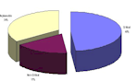
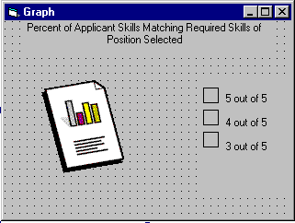

This form is triggered on the click of the Show Graph Button.
The graph shows the percentage of Applicant Skills matching required skills of the Position selected.

Apply For Position Form (Web Site)

The ASP form will be a web based interface page which can be accessed over the internet by an applicant. It will allow the applicant to send an E-Mail to the Recruiter giving them their ApplicantID number as well as the PositionID for the job they are applying for.

1

2
3
4

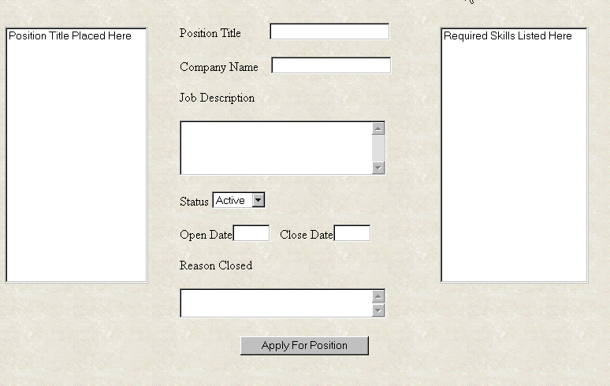
9
5
6
7
8
10

Apply For Position Form

 | Name | Type | R/W | Description
1 | Positions | Listbox | R | Provides a list of all the positions currently availiable through TriLam
2 | Position Title | Textbox | R/W | States the full position title.
3 | Company Name | Textbox | R/W | States the Company with which the selected position is with.
4 | Job Description | Textbox | R/W | Provides the position description as provided by the company.
5 | Status | Combo Box | R | States whether or not the Position is Active or Closed
6 | Open Date | Textbox | R/W | When the position was first posted
7 | Close Date | Textbox | R/W | When the position was or will be closed
8 | Reason Closed | Textbox | R/W | States the reason for which the position was closed.
9 | Required Skills | Listbox | R | Provides a list of industry skills required by the company for this position
10 | Apply For Position | Button | …… | Allows the user to apply on-line for a selected position by requesting their applicant ID and assigning it to the selected position ID.

Input Box for Apply for Position Form

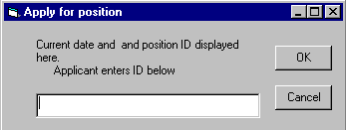
1
2
3

This form is triggered on the click of the Apply button.
The Applicant ID will be entered into the textbox (1). A
mouse-click of the “OK” button (2) will save the entered information and enter it into the Positions Table, and the user will be returned to the Apply for Position form. A mouse-click of the “Cancel” button (3) will cancel the process, no Applicant ID will be saved, and the user will return to the Apply for Positon form.

Security Form

This form is used to restrict access to the application to those individuals who have a valid user name and a valid password.

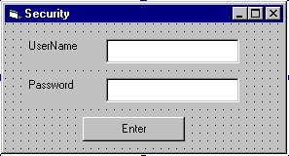
1
2
3

This form is triggered on the MDI Load event.
The UserName will be entered into the textbox (1). The Password will then be entered into the textbox (2). When the user presses Enter the UserName and Password will be verified. If correct, the user will be able to access the Application.

3.0 Implementation – Centered Design Document

3.1 3-Tier Services Model for TriLambda Employment Solutions

User Services

Name | Description
frmMDI | The MDI form provides a means to access the other forms in the application. It is a secure form which only allows a user with a password to enter the application.

Name | Description
frmCompany | The company form will allow the Recruiter to create or edit a profile of a client company.

Name | Description
frmPosition | The position form will allow the Recruiter to create or edit profiles of various positions. From the positions form the Recruiter will be able to access a list of applicants by pressing the View Applicant’s List button. The Recruiter will also be able to open the Skills form to view a list of industry skills required for each position.

Name | Description
frmApplicant | The applicant form will be used by the Recruiter to create or edit applicant profiles. The Recruiter will also be able to open the Skills form to view a list of industry skills possessed by each applicant.

Name | Description
frmSkill | The skill form will be used by the Recruiter to add or edit the list of industry skills. It will also be used when creating or editing applicant or position profiles.

User Services

Name | Description
frmFindPosition | The find position form will be used to view a list of applicants and the jobs best suited for a selected applicant. It will also be used to place applicants in a particular position.

Name | Description
ASPApplyForPostion | The ASP form will be a web based interface page which can be accessed over the internet by an applicant. It will allow the applicant to send an email to the Recruiter giving them their ApplicantID number as well as the number of the PositionID of the job they are applying for.

Name | Description
frmSecurity | This form is used to restrict access to the application to those individuals who have a valid user name and a valid password.

Data Service Classes

Name | Description
cCompanyDB | Handles the data for the Company object.

Name | Description
cPositionDB | Handles the data for the Position object.

Name | Description
cApplicantDB | Handles the data for the Applicant object.

Name | Description
cSkillDB | Handles the data for the Skill object.

Name | Description
cSecurityDB | Handles the data for the Security object.

Name | Description
cDataAccess | Handles the data for the database.

Business Services

See Section 1.0 Goal-Centered Design Document for information on Business Services

Data Services

companyDB Methods | Description
getList() | Takes a list from the database of all the companies that have been saved.
getProfile() | Gets the profile of a specific company from the database and sends it to cCompany.
saveData() | Saves new valid data about the company to the company table in the database.

positionDB Methods | Description
getList() | Takes a list of positions from the database of all the positions that have been saved.
getProfile() | Gets the profile of a specific position from the database and sends it to cPosition.
saveData() | Saves new and valid data about the positions to the postions table in the database.

applicantDB Methods | Description
getList() | Takes a list of Applicants from the database of all the Applicants that have been saved.
getProfile() | Gets the profile of a specific Applicant from the database and sends it to cApplicant.
saveData() | Saves new and valid data about the applicants to the applicant table in the database.

skillDB Methods | Description
getData() | Retrieves data pertinent to a skill from the skills table in the database and sends it to cSkill
saveData() | Saves new and valid data about the skills to the skill table in the database.

securityDB Methods | Description
getSecurityInfo() | Retrieves information about user names and passwords from the database and sends it to the cSecurity.

Data Services

dataAccess Methods | Description
openDataBase() | Allows the BODT’s to access information in the database, either for retrieval or storage.
closeDataBase() | Allows the closure of the database after the information has been retrieved or stored.
retrieve() | Gets data from the database and sends it to the object which has requested it.
store() | Saves valid information to the database.

Data Access Architecture

The VPA application will be divided into five distinct components (see Component Diagram below). The first of these is the Active Server Page component, and will consist solely of the ASPApplyForPositions class. The remainder of the User Services tier (in the 3-tier model) will be in a separate component, the Interface EXE. This EXE will be installed on the end user’s computer and will use COM to communicate with both the business rules (in the Employment DLL, also on the user’s computer) and the security DLL (again, on the user’s computer). The Security is placed in a component apart from the Employment DLL, since it is possible to visualize a scenario where another application may want to have access to the Security class. All of the classes in the Data Services tier (which includes a BODT for each object in the business services tier, and the DataAccess class) will be incorporated into the Data Services DLL; this will be installed on a server apart from the user’s computer. Communication between the distributed components will be accomplished using DCOM, and ADO will facilitate database access by the BODT objects in the Data Services DLL.

3.2 Component Diagram

TriLambda Employment Solutions

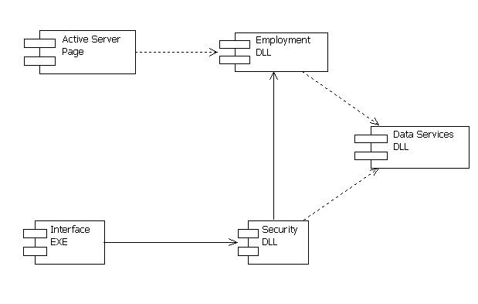

3.3 Definitions of Classes

Component Name | Assigned Classes | Description
Active Server Page | ASPApplyForPosition | The Active Server Page is created to allow the Web User to apply directly for a position, via the internet.
Interface EXE | frmMDI | This is the main form, from which the Recruiter may access the other forms.
Interface EXE | frmCompany | This form is used to maintain client companies.
Interface EXE | frmApplicant | This form is used to maintain applicants.
Interface EXE | frmPosition | This form is used to maintain positions.
Interface EXE | frmFindPosition | This form is used to find positions for applicants.
Interface EXE | frmSkill | This form is used to maintain skills.
Interface EXE | frmGraph | This form will display a pie chart representation of the position/applicant skill matching.
Interface EXE | frmSecurity | This form will restrict access to the application to those individuals with valid usernames and passwords.
Employment DLL | cApplicant | This class manages information about applicants within the VPA.
Employment DLL | cCompany | This class manages information about client companies.
Employment DLL | cPosition | This class manages information about positions.
Employment DLL | cSkill | This class manages information about industry skills.
Employment DLL | colSkills | The Skills collection manages the set of skills in the Skill class.
Security DLL | cSecurity | The Security class manages information about usernames and passwords.
Data Services DLL | cSecurityDB | The Security BODT is responsible for the passage of data from the Security class to the cDataAccess class.
Data Services DLL | cSkillDB | The Skill BODT is responsible for the passage of data from the Skill class to the cDataAccess class.
Data Services DLL | cPositionDB | The Position BODT is responsible for the passage of data from the Position class to the cDataAccess class.
Data Services DLL | cApplicantDB | The Applicant BODT is responsible for the passage of data from the Applicant class to the cDataAccess class.
Data Services DLL | cCompanyDB | The Company BODT is responsible for the passage of data from the Company class to the cDataAccess class.
Data Services DLL | cDataAccess | The DataAccess class provides and manages access to the database, through ADO.

3.4 Deployment Model Diagram

TriLambda Employment Solutions

The deployment diagram defines the physical architecture for where to distribute the components. It is this architecture that decides if the entire application will be run on each user’s computer, or if some of the components will run on shared systems. The Recruiters will each be provided with the application and access to the DataAccess class through the BODT classes which communicate with the Business classes contained within the application. The Web User accesses the information through an active server page accessed through the SQL Server. The Server node physically contains the database and the BODT’s which regulate admittance to the Database information.
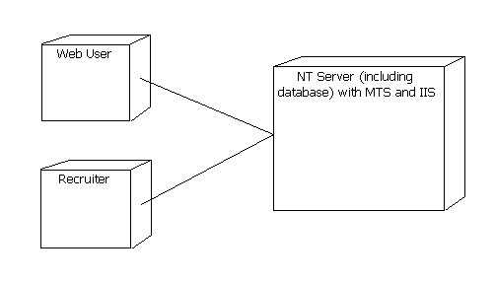

Name | Type | Description
Web User | Node | Allows a person to access the application through the SQL server.
Recruiter | Node | The recruiter has the actual application on their computers in order to better match applicants and positions.
Server | Node | Contains the BODT, DataAccess, and DataBase allowing both the other nodes access to required information

4.0 Data Design Document

4.1 High Level Data Design

Guidelines on Database Construction

The idea behind constructing our database is for the safe storage and retrieval of information between our web interface and the database itself. The goal is to create a user-friendly database that will have multiple ways for manipulating data.
The ICD will be used as a template for the proper table and field divisions that will be used to build a database.

4.2 Database Design

ERD – TriLambda Employment Solutions
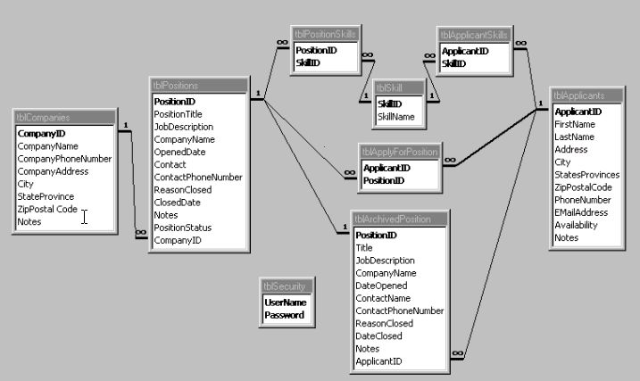

Data Dictionary – VPA Tables

tblSecurity
Field Name | Data-Type | SSize | Required (Yes/No) | Default Values | Comments
User-Name | String | 15 | Yes | None | PK Identifies specific user-name for each user.
Password | String | 20 | Yes | None | PK Identifies specific password for each user.

tblCompany
Field Name | Data-Type | SSize | Required (Yes/No) | Default Values | Comments
Company ID | AutoNumber | N/A | Yes | None | PK Unique number for each company. Creates a one to many relationship with the Position table.
Company Name | String | 20 | Yes | None | Identifies the name of the company in question.
Phone # | Integer | N/A | Yes | None | Identifies company phone number.
Address | String | 30 | Yes | None | Identifies the company’s physical address.
City | String | 15 | Yes | None | Identifier for the city where the company is located.
State/Province | String | 2 | Yes | None | Identifier for the state or province the company is from. Chosen from a combo box.
Zip/Postal Code | String | 7 | Yes | None | Identifies the company’s zip or postal code.
Notes | String | 50 | No | None | Space for any additional comments to be made on the company.

tblPosition
Field Name | Data-Type | SSize | Required (Yes/No) | Default Values | Comments
Position ID | AutoNumber | N/A | Yes | None | PK Unique identifier for each Position and used to create a one to many relationship with the Position Skills table, with the Archived Position table, and with the Apply For Position table.
Title | String | 15 | Yes | None | Identifies the Full Position title of the selected position
Job Description | String | 35 | No | None | Identifies the full job description as given by the company.
Company Name | String | 20 | Yes | None | Identifies the name of the position’s company
Date Opened | Date | N/A | Yes | None | Identifies when the position was first posted
Contact Name | String | 15 | Yes | None | Identifies Person at the company to contact concerning the selected position
Contact Phone # | Integer | N/A | Yes | None | Identifies the contact person’s phone number
Reason Closed | String | 35 | No | None | Identifies the reason for which the position is no longer available
Date Closed | Date | N/A | Yes | None | Identifies when the position was or will be closed
Notes | String | 50 | No | None | Space for any additional comments to be made on the position.
Status | String | 10 | Yes | Active | Whether the position is Active or Closed
Company ID | Integer | N/A | Yes | None | FK Used in the one to many relationship with the Company table.

tblPositionSkills
Field Name | Data-Type | SSize | Required (Yes/No) | Default Values | Comments
Position ID | Integer | N/A | Yes | None | PK/FK Completes the one to many relationship to the Positions table.
Skill ID | Integer | N/A | Yes | None | PK/FK Creates one to many relationship with the Skills table

tblApplicant
Field Name | Data-Type | Size | Required  (Yes/No) | Default Values | Comments
Applicant ID | AutoNumber | N/A | Yes | None | PK Assigns a unique number for each applicant and used to create the one to many relationship with the Applicant Skills, Archived Position, and the Apply For Position tables.
First Name | String | 15 | Yes | None | Identifies the first name of the applicant
Last Name | String | 20 | Yes | None | Identifies the last name of the applicant
Address | String | 20 | Yes | None | Identifies the applicant’s physical address.
City | String | 15 | Yes | None | Identifier for the city where the applicant is located
State/Province | String | 2 | Yes | None | Identifier for the State or Province the applicant is from. Chosen from a combo box.
Zip/Postal Code | String | 7 | Yes | None | Identifies the applicant’s zip or postal code.
Phone Number | Integer | N/A | Yes | None | Identifies the applicant phone number
E-Mail | String | 20 | Yes | None | Identifies the applicant’s e-mail address
Availability | Yes/No | N/A | Yes | Yes | Identifies whether or not the applicant is currently available for placement.
Notes | String | 50 | No | None | Space for any additional comments to be made on the applicant.

tblApplicantSkills
Field Name | Data-Type | SSize | Required (Yes/No) | Default Values | Comments
Applicant ID | Integer | N/A | Yes | None | PK/FK Completes the one to many relationship to the Applicants table.
Skill ID | Integer | N/A | Yes | None | PK/FK Creates one to many relationship with the Skills table

tblSkill
Field Name | Data-Type | Size | Required (Yes/No) | Default Values | Comments
Skill ID | AutoNumber | N/A | Yes | None | P/K Assigns an unique number for each skill Used in the one to many relationship with the Position Skills and the Applicant Skills tables.
Skill Name | String | 10 | Yes | None | Identifies the name of the industry

tblApplyForPosition
Field Name | Data-Type | Size | Required (Yes/No) | Default Values | Comments
Applicant ID | AutoNumber | N/A | Yes | None | PK/FK Used in the one to many relationships with the Applicants and the Apply For Position tables.
Position ID | String | 10 | Yes | None | PK/FK Used in the one to many relationships with the Positions and the Apply For Position tables.

tblArchivedPositions
Field Name | Data-Type | SSize | Required (Yes/No) | Default Values | Comments
Position ID | AutoNumber | N/A | Yes | None | Unique identifier for each Position P/K Used in the one to one relationship with the Position table.
Title | String | 15 | Yes | None | Identifies the Full Position title of the selected position
Job Description | String | 35 | No | None | Identifies the full job description as given by the company.
Company Name | String | 20 | Yes | None | Identifies the name of the position’s company
Date Opened | Date | N/A | Yes | None | Identifies when the position was first posted
Contact Name | String | 15 | Yes | None | Identifies Person at the company to contact concerning the selected position
Contact Phone # | Integer | N/A | Yes | None | Identifies the contact person’s phone number
Reason Closed | String | 35 | No | None | Identifies the reason for which the position is no longer available
Date Closed | Date | N/A | Yes | None | Identifies when the position was closed
Notes | String | 50 | No | None | Space for any additional comments to be made on the position.
Applicant ID | Integer | N/A | No | None | F/K used in the one to many relationship with the Applicants table.

4.3 Queries

Queries can be used to give the database better functionality.
Examples of possible queries would include:

Query | Parameters | Description
View Active Positions | Status Field Value = “Active” | This would query the “Positions” table and show only the positions that have the value of “Active” in the “Status” field.
View Available Applicants | Availability Field Value = “Yes” | The “Applicants” table will return the records that have “Yes” as the value in the “Availability” field.
Gather Applicant Email Addresses | Applicants Table, Email Field Search by name field. | Queries the “Applicants” table and returns Email addresses for a user specified range of applicants.
Find Applicants or Positions by Skill Set | Skills With Field Value = “Yes” | This involves Querying either the “Applicant Skills” or the “Position Skills” tables to return a specified skill set.

4.4 Configuration Settings

We will use an ADO interface to our database and employ Microsoft Access for the creation of the database. All data storage and archiving will all have Microsoft Access formatting.

5.0 Strategies for Construction

5.1 Detailed Work Plan

See Appendix C for a detailed work plan

5.2 Development Framework

See Appendix D for Code Estimates Document and Implementation Plan

Quality Assurance

The following are the primary quality assurance techniques used during this phase:

Coding standards and naming conventions.
During the development, all programmers will follow formal coding standards and naming conventions. This ensures consistent coding styles which makes the programs easy to read by the entire project team.

Code Reviews.
Throughout the development, there will be formal joint code reviews. This technique has a number of major benefits. Early detection of design and coding flaws, encouraging code reuse, ensuring compliance to standards, providing valuable and early feedback to programmers, as well as gives all programmers a broad understanding of the entire system.

Unit test checklists.
After a module has been reviewed and completed, the programmer must complete a formal unit test cycle and complete a checklist. This ensures that the basic functionality has been tested and works prior to it being released.

The following are the primary quality assurance techniques used during this phase:

Formal test plans.
Each test cycle will follow a predefined test plan. This will ensure that nothing is overlooked during the testing phase.

Incident Tracking.
During the testing phase, any incidents or events that may occur, must be fully documented. These incidents must be prioritized according to the specifications from the client company.

System Testing.
System testing ensures that all system components mesh as expected and satisfy design specifications and business scenarios as planned. We may then perform such testing as is necessary to address configurations and stress issues

User Testing.
Once the system test is completed, a formal user acceptance test will begin. The purpose of this test is to have the actual end-users test the system in their business environment. This provides one more opportunity for the users to verify the system, prior to it being deployed.

Training Evaluations.
At the conclusion of the training, each trainee will be given evaluation forms assessing both strengths and weaknesses of the training. The training may then be modified as warranted.

Skills Checklists.
At the conclusion of the training, each trainee will be given skill checklists assessing the efficiency of the tasks required of them to perform. This is to ensure that all employees feel comfortable with the system, and allow for changes to be made if this is not being met.

